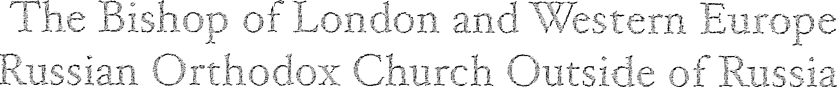
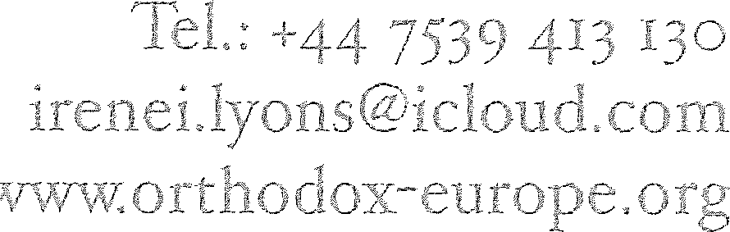

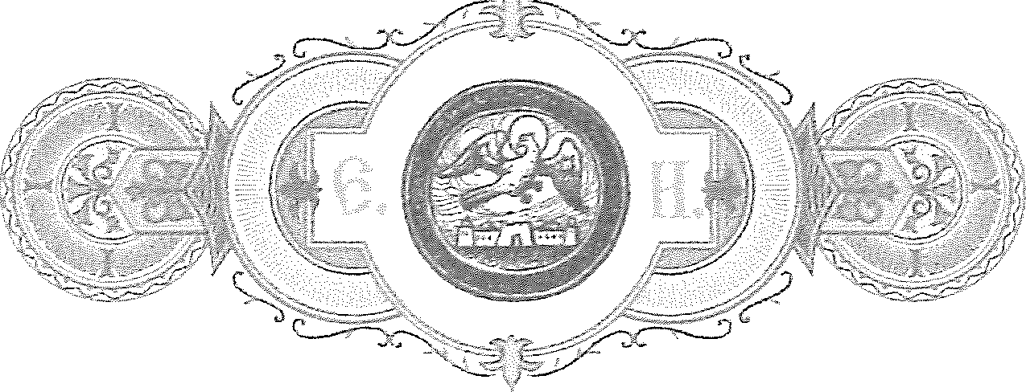
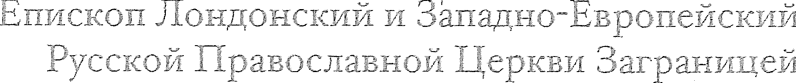
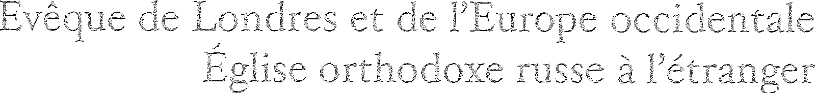
359/E ro / 23January 2.]2[

DIRECTIVE
To the Very Reverend and Reverend Priests of the Diocesan Region of the British Isles

Dear in Christ, Very Reverend and Reverend Fathers!

I regret that it is necessary to write to all Priests of our Diocesan Region of the British Isles to address the escalation of a serious issue that has arisen with the Archdiocese of Orthodox Russian Tradition Churches in Western Europe (l'Archeveche des Eglises Orthodoxes de Tradition Russe en Europe Occidentale, often known in the UK informally as 'the Exarchate'). I had previously addressed this matter in a more localised manner in a Directive issued solely to our clergy in Wales and the immediate environs (issued in our correspondence no. 347/UK/E of 9th/ 22nd December 2020) in the hopes that a broader redress of the situation would not be required whilst the matter was addressed with the Hierarchy of the Exarchate. However, as it has now been over a month since my first correspondence with that Hierarchy, with follow-up correspondence issued in the interval, without acknowledgement or response, and as the matter itself is escalating, I have no option but today to extend this further, to the whole of our Diocesan presence in the British Isles.
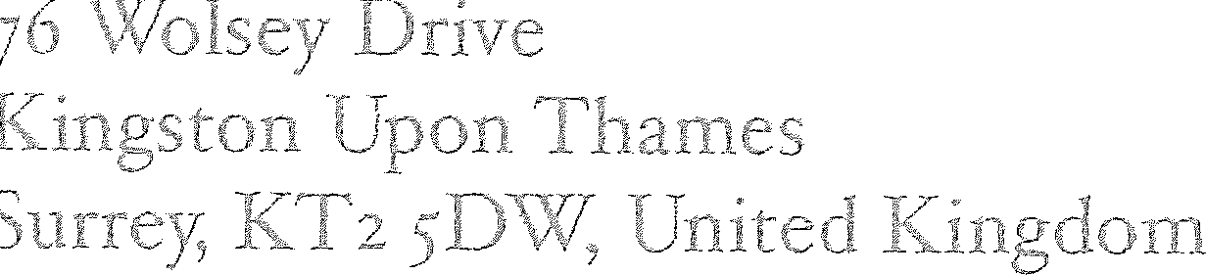
For Your information, the matter relates to the 'reception' on 4th / 17th December 2020 by the Archdiocese of an heterodox individual by the name of James Siemens, resident in the environs of Cardiff, Wales, purportedly into the ranks of the Holy Orthodox Clergy but in a manner that appears to us to be in violation of the Holy Orthodox Canons as well as the firm practices of the Russian Orthodox Church as a whole: namely, that this individual, who was a Ukrainian Catholic Uniate priest, was 'received' into Orthodoxy apart from the sacramental measures of Baptism or Chrismation, and further, was thereafter acknowledge as an Orthodox Priest, without having an Orthodox ordination. While the former situation (reception into Orthodoxy 'by confession') is canonically highly irregular, but not an entirely unprecedented misapplication by economia of the canonical measures meant to apply to one who has an Orthodox baptism/chrismation and returns from schism (in this case, improperly applying it to a man who never had either), the latter issue, of 'recognising' a heterodox ordination as if it constituted the establishment of a man as an Orthodox priest, is wholly uncanonical and goes against the most basic foundations of the Holy Orthodox Church, to whose true nature we are all called to be obedient and, when it is challenged, to defend, for the sake of the faithful. The Archdiocese appears to have precisely repeated the grave error of Patriarch Bartholomew, who in his self-exaltation has proclaimed that the canons are irrelevant so long as he makes a decision under his own

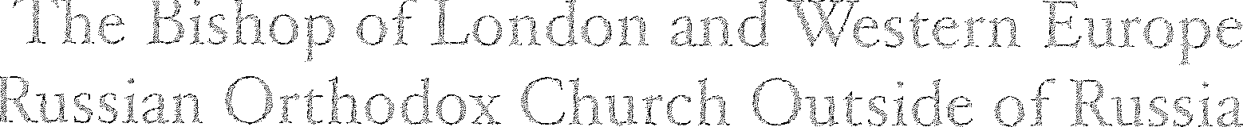
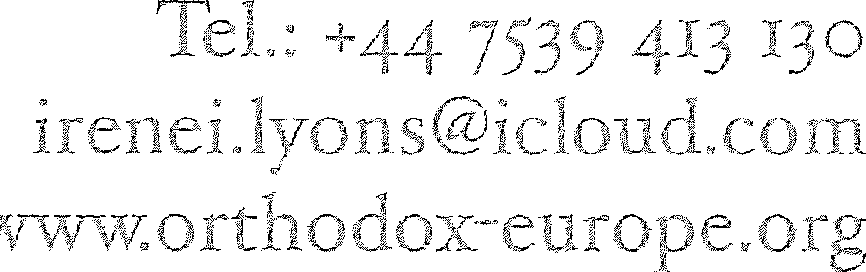

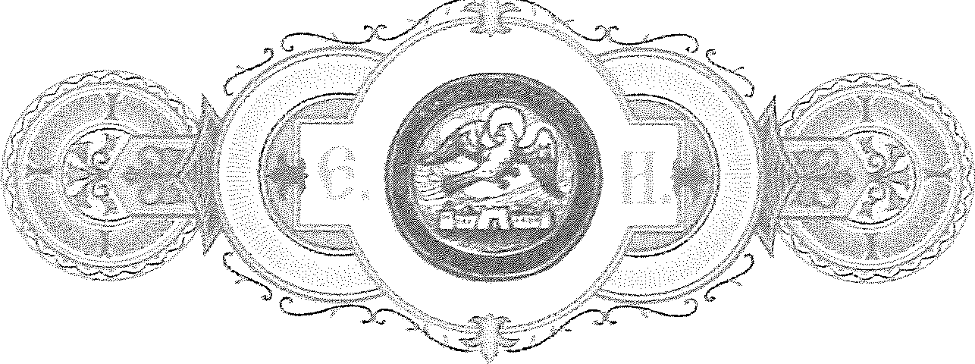
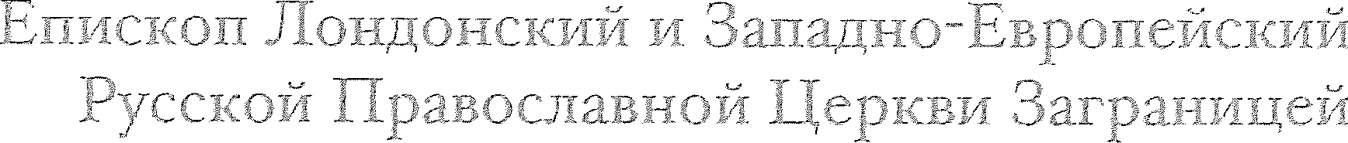
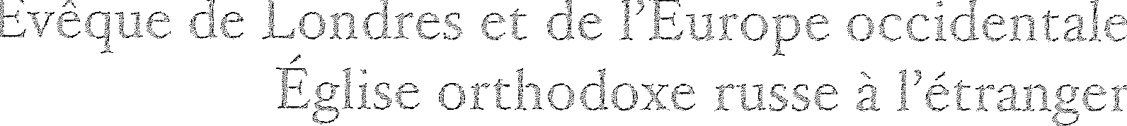
authority, proclaiming by personal.fiat that a heterodox person is Orthodox, and that a non­ priest is a priest. This is a falsehood and a deception, and if it is wrong for Patriarch Bartholomew to do it, it is wrong also for any other Hierarch to do likewise.
My initial response was restricted solely to the region of Cardiff, where this individual resides and intends to start a parish presence, prayerfully hoping that the matter could be addressed with the Archdiocese and this error resolved. I am still hopeful that this might be possible, and continue to try to engage the Hierarchy of the Archdiocese in the matter on which they have thus far declined to respond; however, as in recent days 'liturgical' celebrations have been held with this individual, as well as interviews and articles about his 'reception' into Orthodoxy published on web sites and social media, the spread of this error has grown and now has the potential to ensnare more innocent faithful in the British Isles, and must be addressed in a wider scope. Therefore, we hereby direct that, from today's date and as a temporary measure during the period required to investigate and address this matter at the appropriate level of the Higher Church Authorities, You may neither concelebrate nor participate liturgically, or in any ecclesiastical measure, with the aforementioned James Siemens, nor with any clergy or local institutions of the Archdiocese / Exarchate in the British Isles. Further, if You have any spiritual children or parishioners who at times have attended Exarchate parishes in the UK for reasons of proximity, etc., you must inform them that until this matter is resolved, they may not receive the Sacraments at any parish of the Exarchate in the British Isles.
I realise that this is a deeply sorrowful matter, and pray it will be temporary and resolved swiftly according to the canonical order of the Church; but in the meantime, it is an absolute pastoral necessity. So far as we have been able to discern, James Siemens has no Orthodox ordination - therefore his being proclaimed a 'priest' and charged to undertake pastoral labours represents a direct and immediate cause of spiritual peril to innocent faithful who will not necessarily understand that, in the context of a non-priest, no authentic sacraments can be performed; nor, that by 'concelebrating' with a non-priest, other clergymen of the Exarchate betray the divine grace of their ordination, mixing falsehood with truth and placing the faithful before them in grave peril by offering non­ sacraments in the place of the true and life-creating Sacraments that are offered only in the purity of the Church by those ordained with the grace so to do. This is a most grievous situation that requires immediate correction, or it will threaten the relations between our Churches on a broader level in the nearest future.
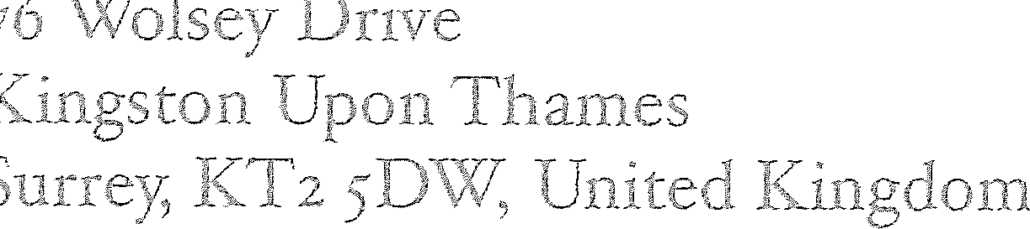
My dear Fathers: You may share the substance of this Directive with such individuals as You deem it appropriate to know these details, in order for You to fulfil Your obediences properly; however, I expressly forbid this matter becoming the subject of publication or public chatter, on-line or elsewhere, or the discussing of it beyond those contexts where such discussion is an absolute pastoral necessity. I have no desire to create a public spectacle out of what is a most sorrowful matter, especially as we so recently were

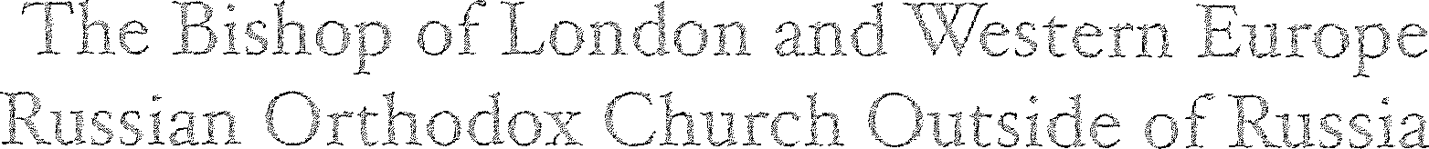
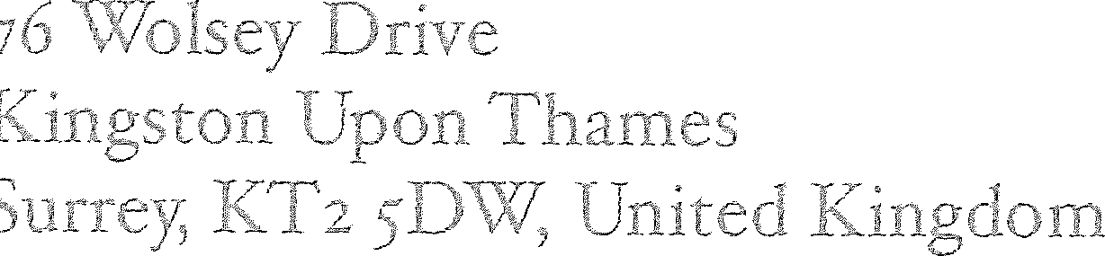
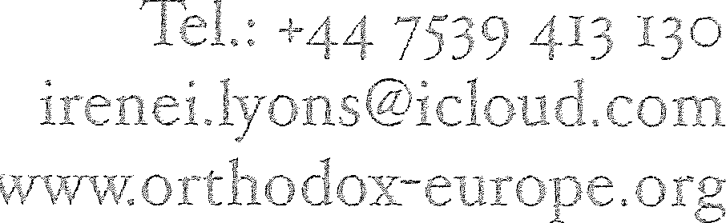

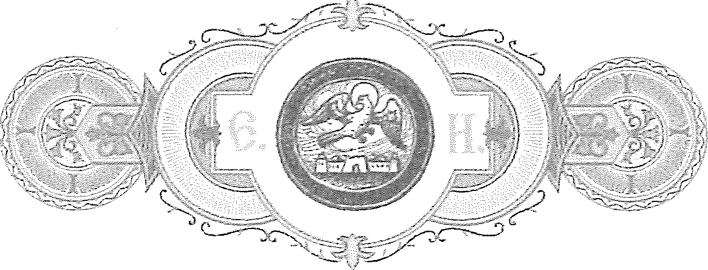
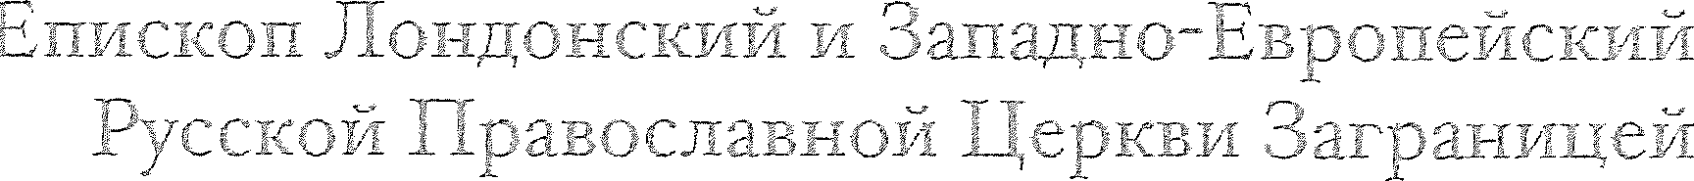
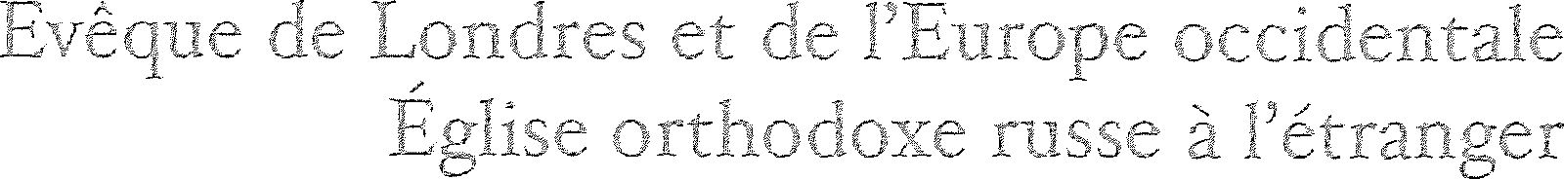
rejoicing at the return of the Archdiocese to its Mother Church - and hope and fervently pray for this matter to be resolved, not further exacerbated by fruitless talk or gossip. It is true that trials come with every blessing. I ask You also, therefore, of your charity to pray for James Siemens. If it is indeed the case that, despite his past demonstrations of open and aggressive animosity towards the Moscow Patriarchate and our own Church Abroad, this man wishes to repent of his errors and be received into Holy Orthodoxy, then he has been provided with an unnecessary trial through these irregular actions.
If You have questions about this directive, please contact me directly via telephone, or via the Chancellery at any time. May the Lord our God bless You!

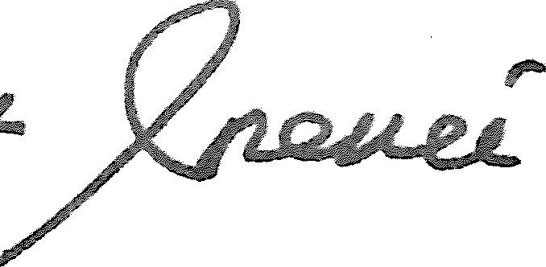
Bishop of London and Western Europe, Russian Orthodox Church Outside of Russia
